**Pythoplat**

**Algorithm**

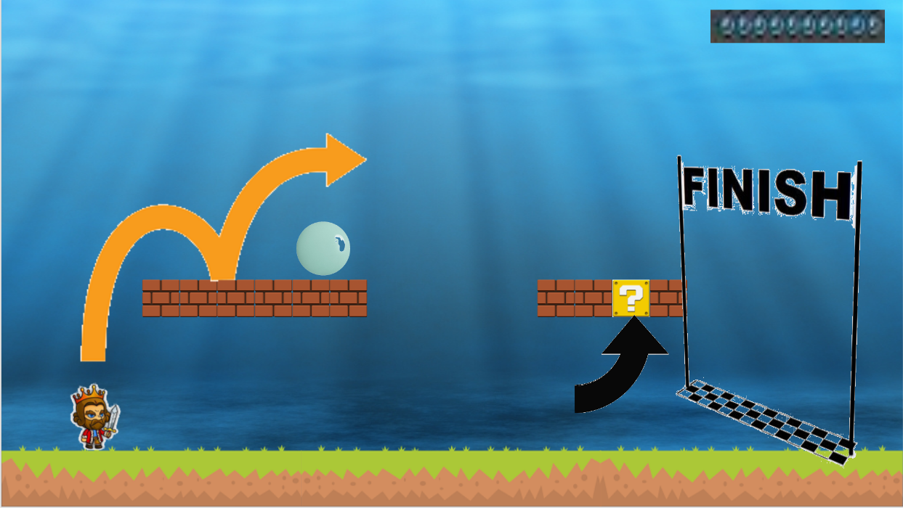

**Mesatronix Inc.**

*Manuel Quinones, Sunny Jin, Matthew Wong*

**Import gamelib**

**Create a variable for the Game object**

**Create variables for graphics:**

1. Create an Image variable for “background.png” (background)
2. Resize the background image to the screen dimensions
3. Create an Image variable for the “king.png” (hero/main character)
4. Resize the king variable to make it more reasonable
5. Create an Image variable for “groundn.png” (floor)
6. Create another Image variable for “groundn.png” (floor)
7. Move the ground to the bottom of the screen
8. Resize both of the ground variable
9. Move the king to make it look like he’s standing on the ground
10. Create a variable for jumping
11. Create a variable for landing
12. Create a variable for factor
13. Create a List variable for “Brick.png, game” (The platform we will be jumping on)
14. Move the brick to be a more reasonable location
15. Resize the brick for it to be smaller
16. Create a Image variable for “Spike.png, game” (1 of the things that the king will take damage from)

**Create 4 sound variables.**

Set the game background to the day image (needed to scroll)

**Create an start screen:**

1. Draw the background
2. Draw the logo
3. Draw the text - “Press spacebar to start game”
4. Update the game screen
5. Add game wait time until player presses space bar

**Add the game loop**

1. Process the inputs
2. Draw the background
3. Draw the king
4. Draw the ground
5. Copy jump function we were given
6. Change around the jump for it to be more reasonable in our game
7. Set the key A for the king to move left
   1. While on holding the ground will move left
8. Set the key D for the king to move right
   1. While on holding the ground will move right
9. Set the key SPACE for the king to jump
10. Update the screen

**Add the ending Screen**

1. Draw the gameover image
2. Draw the text “press enter to end the game”
3. Update the screen
4. Add the game’s wait until the player presses the Enter Key
5. Quit the game